## National University of Computer & Emerging Sciences, Karachi Artificial Intelligence-School of Computing



**Fall 2023, Lab Manual - 04**

|  |  |
| --- | --- |
| **Course Code (AI4002)** | **Course: Computer Vision Lab** |
| **Instructor(s):** | **Sohail Ahmed** |
| **Name:** | **Manahil Fatima Anwar** |
| **Roll Number:** | **20K-0134** |
| **Section:** | **BAI-7A** |

## Tasks

* + - 1. Complete the above codes where the lines are missing.

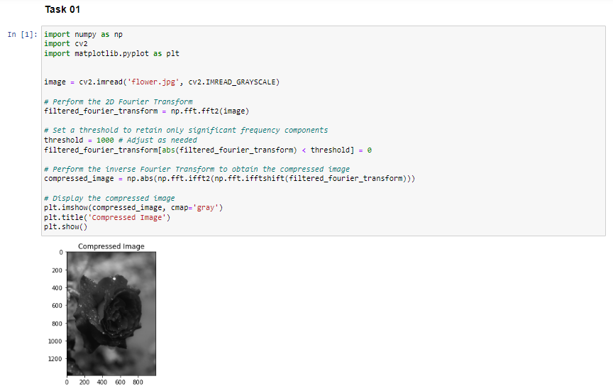

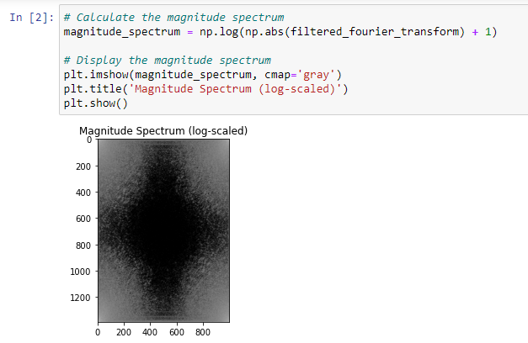

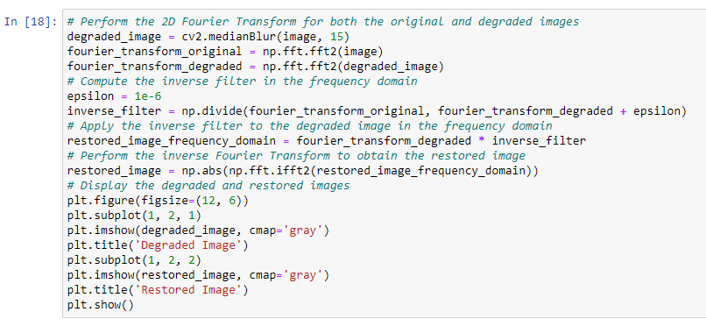

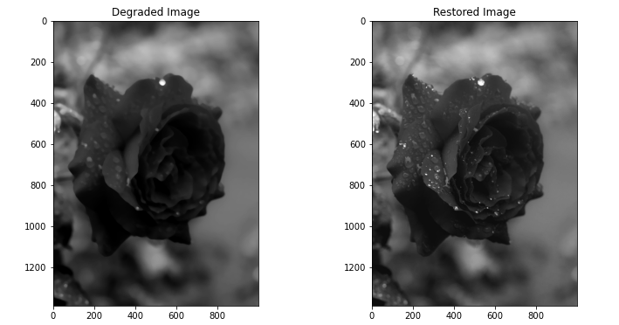

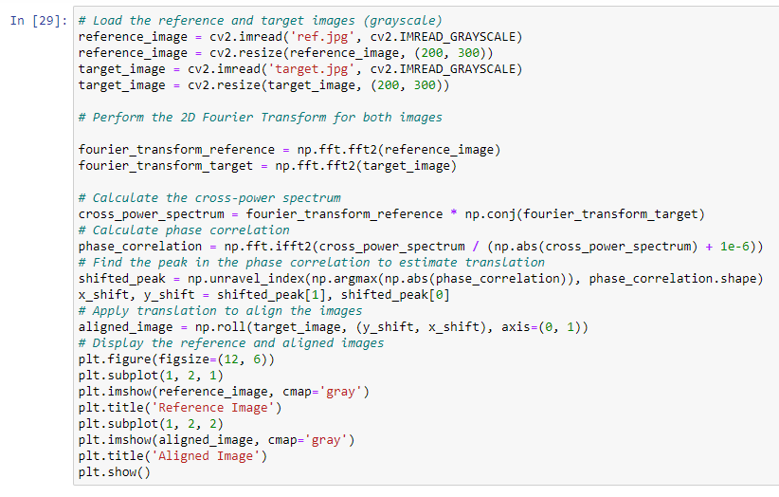

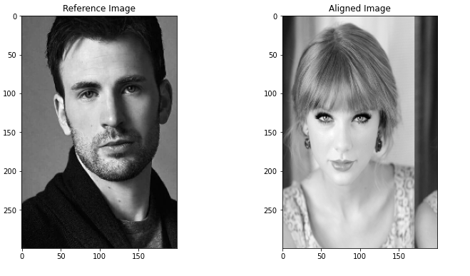

## Linear Filtering:

* + - * + Implement a Gaussian blur filter using convolution for image smoothing.
        + Apply a Sobel filter to perform edge detection on a grayscale image.
        + Perform image sharpening using the Laplacian filter.
        + Implement a mean filter for noise reduction in an image.

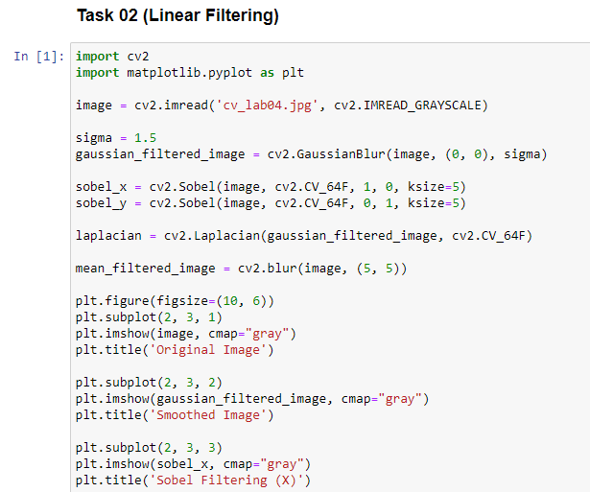

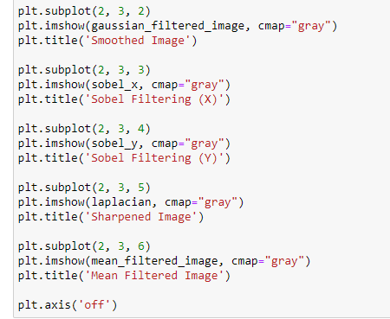

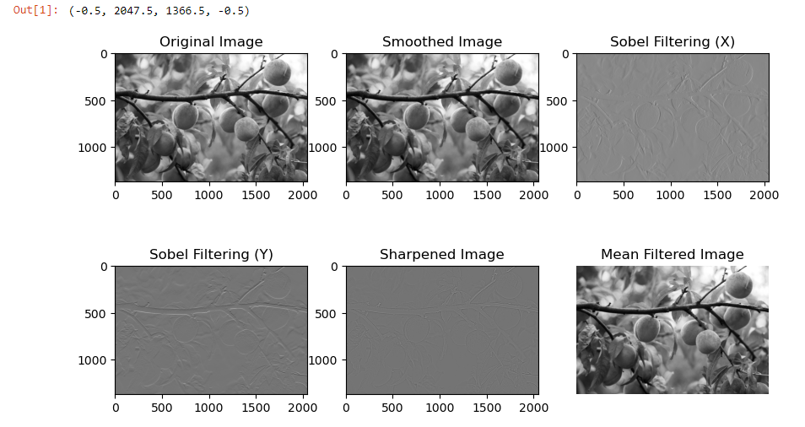

## Non-Linear Filtering:

* + - * + Develop a median filter for removing salt-and-pepper noise from an image.
        + Apply a max filter to perform dilation on a binary image.
        + Implement a min filter to perform erosion on a binary image.
        + Create a bilateral filter for edge-preserving smoothing.
        + Implement an adaptive median filter for noise reduction while preserving edges.

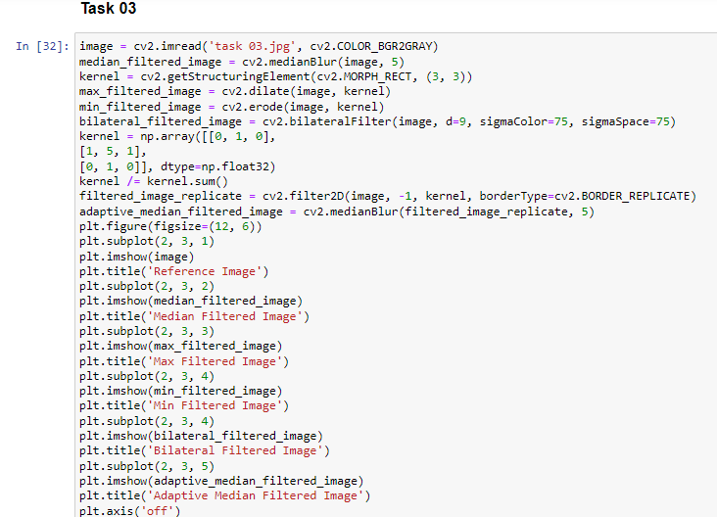

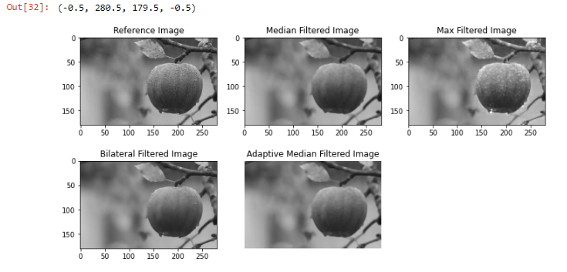

## Fourier Transformations:

* + - * + Calculate the 1D Fourier Transform of a signal and visualize its magnitude and phase spectra.
        + Apply a 2D Fourier Transform to an image and display its magnitude spectrum.
        + Implement a high-pass filter in the frequency domain to emphasize edges in an image.
        + Perform image compression using the Fourier Transformation

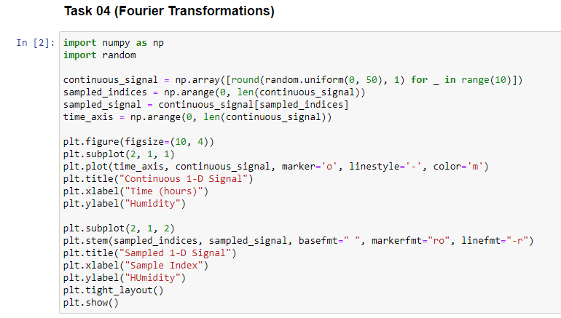

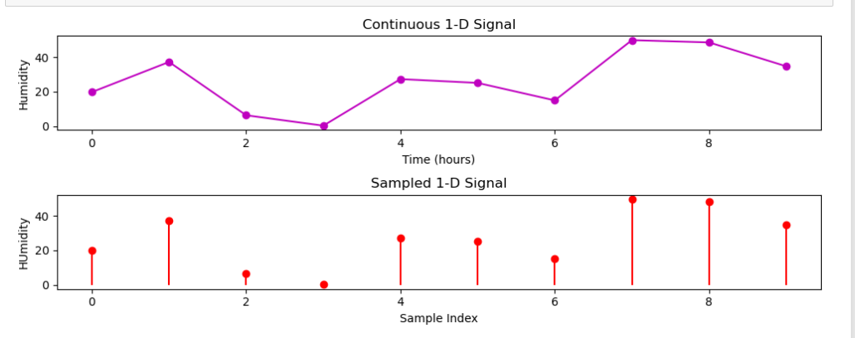

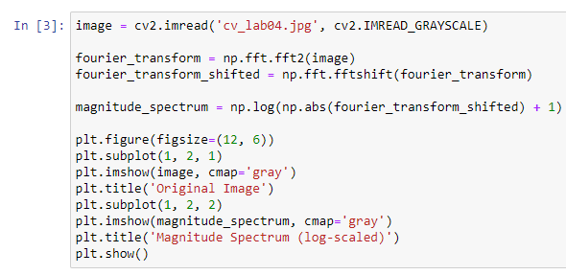

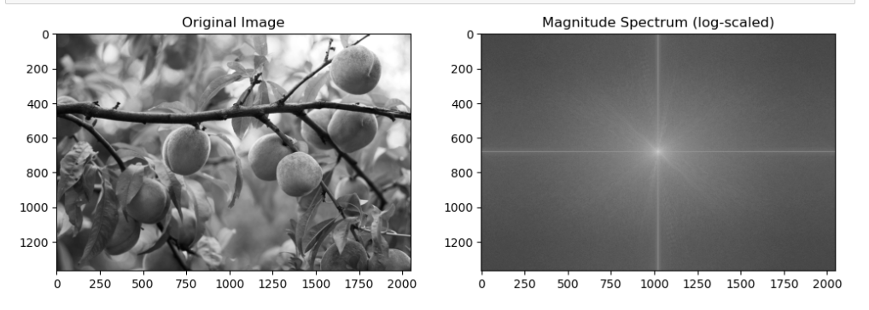

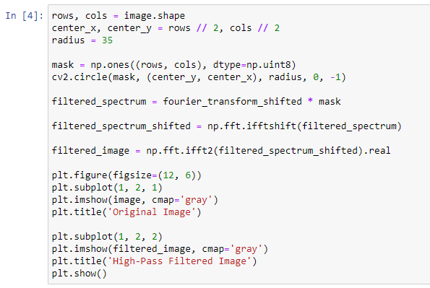

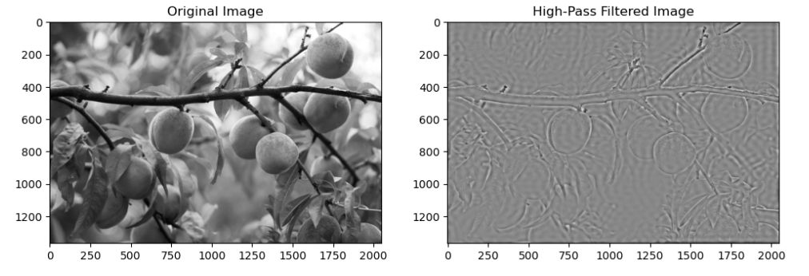

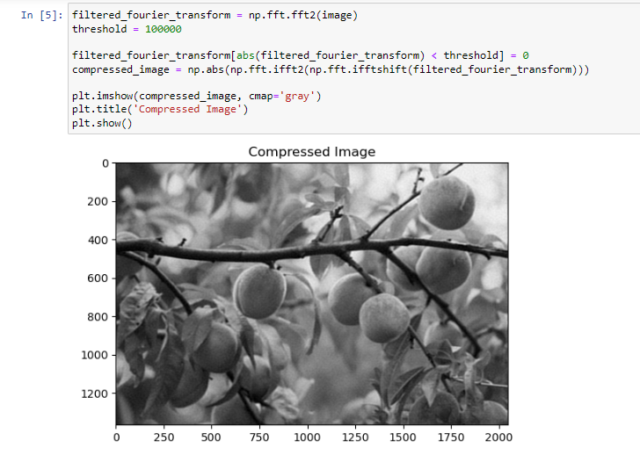

## Hybrid Images:

* + - * + Create a hybrid image from two input images with different spatial frequencies.
        + Experiment with different combinations of high-pass and low-pass filters for hybrid image creation.
        + Generate a hybrid image that exhibits a strong visual illusion when viewed from different distances.
        + Investigate how changing the filter parameters affects the perception of a hybrid image.
        + Analyze the trade-offs between high and low-frequency components in hybrid images for various application.

